**DAILY ONLINE ACTIVITIES SUMMARY**

|  |  |  |  |  |  |  |  |  |
| --- | --- | --- | --- | --- | --- | --- | --- | --- |
| **Date:** | **05/06/2020** | | | | | **Name:** | **RITIKA KULKARNI** | |
| **Sem& Sec** | **4thSEM. & ‘B’ SEC.** | | | | | **USN:** | **4AL19CS403** | |
| **Online Test Summary** | | | | | | | | |
| **Subject** | | **----** | | | | | | |
| **Max. Marks** | | **---** | | **Score** | | | **---** | |
| **Certification Course Summary** | | | | | | | | |
| **Course** | **Python for Machine Learning** | | | | | | | |
| **Certificate Provider** | | | **Greatlearning**  **Academy** | | **Duration** | | | **5 Hrs.** |
| **Coding Challenges** | | | | | | | | |
| **Problem Statement:**  **Write a Java Program to find the duplicate characters in a string.** | | | | | | | | |
| **Status:** | | | | | | | | |
| **Uploaded the report in Github** | | | | | **Yes** | | | |
| **If yes Repository name** | | | | | <https://github.com/ritikakulkarni/QuarantineCoding-JavaCoding/blob/master/DuplicateC.java> | | | |
| **Uploaded the report in slack** | | | | | **Yes** | | | |

**Certification Course Summary: Today I have learnt about the jupyter notebooks ,how to create a new note book and how to execute the code in the cell provided in the notebook and about some of the keyboard shortcuts which helps to execute the code and to achieve the output and some of the basic data structure hands-on.**

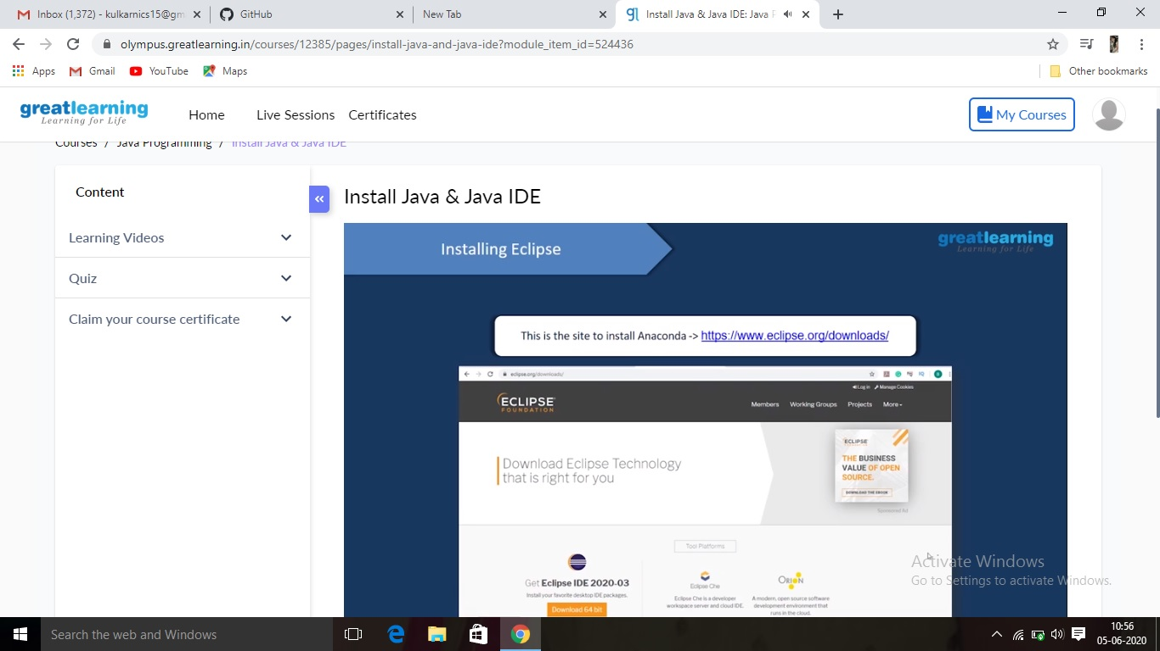

**Online Coding Summary:Online Coding Summary​: Online coding Summary: Today I received one program from Prof.Venkatesh CSE Dept. The program is mentioned above(pg.01). to my GitHub repository and I’ve shared the snapshot below.**

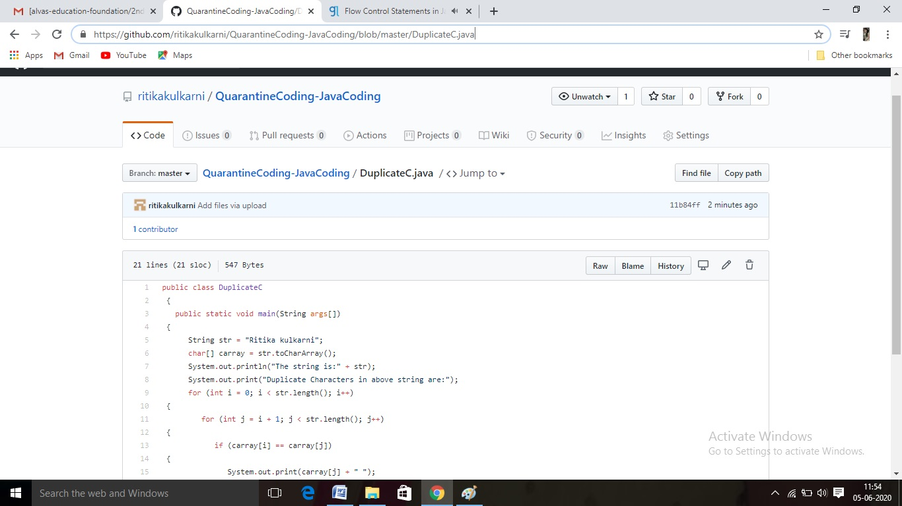

**Thank you.**